# Kingston Supermart sales

Kingston Supermart sales

INTRODUCTION

Questions

The data

Cleaning

Analysis

Pivot tables

Dashboard

Conclusion and Recommendation

## INTRODUCTION

Kinston Nigeria Limited is a group of companies owned by 27 veterans who retired in the mid-2000s. After their retirement, they decided to start different types of business from their pension and gratuity to keep them busy after service. Their venture includes import and export business, processing of raw materials, and merchandising to mention a few.

According to the chairman of the group Austin Robert, due to economic pressure and getting superior supplies, Kingston Supermart is to cater to the needs of their members located in Lagos, Abuja, and Ibadan at a highly discounted price. However normal citizens can also patronize the business but not at the expense of its members who are veterans both in service or retired

## Questions

For this project, every data shared in the project is internally and primarily generated and permission has been fully granted by the owner of the data. Sensitive information has been anonymized. The stakeholders are trying to determine if the business is progressing and if they can expand to other states since this is a pilot project. Other inquiries include

* What is the rate of sales?
* How well are people patronizing the business both member and non-member
* The mode of payment that is most preferred
* How well do they rate the business
* How well is the business making a profit?

## The data

The data is first-party data i.e. it is generated within the organization and it is saved c.s.v file. The data sample given was for the first quarter of 2019 ranging from 1/1/19 to 3/30/19. The data is reliable, original, cited, comprehensive, and current. (roccc). This data is generated from the data activity of the organization.

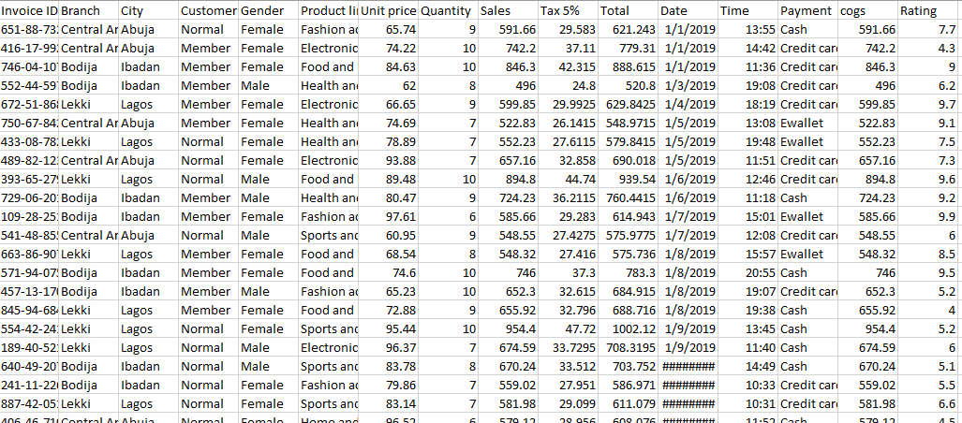

## Cleaning

To put the data in a proper position, intensive cleaning must be done. First, duplicate data was removed using the remove duplicate augment. Other adjustments

Like data conversion was done, the arrangement of the scattered data was then sorted, from ascending to descending order by the product line. Searching for missing values using the find and replace option to replace names that were missing and values that were not well defined. In order to be sure of these values conditional formatting was done using the conditional formatting augment. The date was also readjusted to a proper format and the naira sign was added for proper financial presentation, other cleaning procedure was also done.

## Analysis

For proper analysis, the data was converted into a table format. More column was added to get the gross margin percentage and gross income, for the cost of goods sold tax, and sales were added. For gross margin percentage (sales/sales−COGS)×100, and for gross income (Gross Profit=Revenue−COGS) further analysis was done to know the number of people who came to patronize the stock and goods. Count function was used to divide people into male 106 and female 121 making the total 227. The supermart was designed for veterans but the public can also patronise the stores. The count is also used to separate the member from the normal public. All in all the sales after the quarter is 319,109 using the sum function of the total goods sold while the average is 1,399.

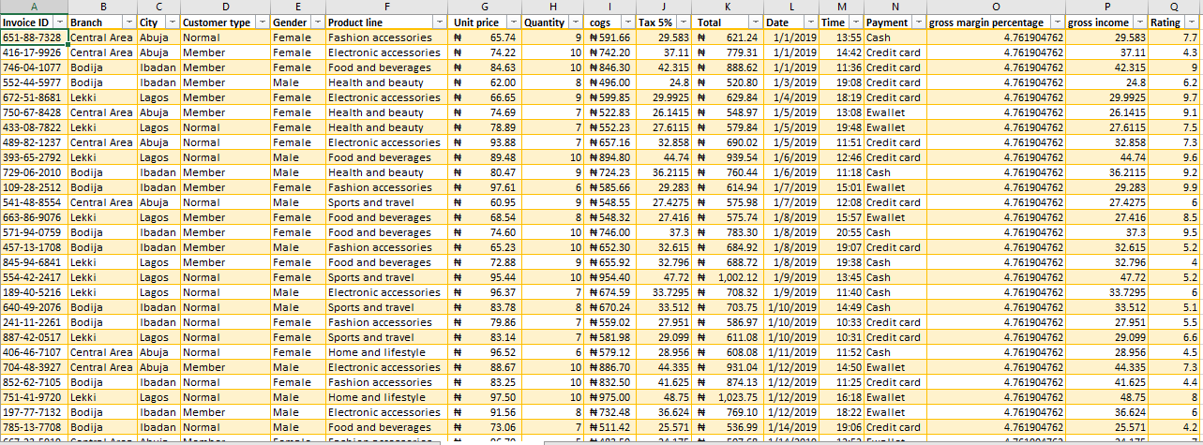

When it comes to mode of payment more people pay by cash than by credit card or e-wallet count result was cash 78, credit card 74, and e-wallet 75. In general, more people are really satisfied with the service and the product of the Kingston supermart. Rating the supermart as high as 68.60352 percent was achieved by dividing the total rating/ no of customers. Gross income is 7597.84 which surpasses the budget.

For products sold the most and the least

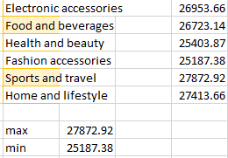

## Pivot tables

After the data was cleaned and analyzed, pivot tables and pivot chart was made which made visualization easy. Below are some of the table

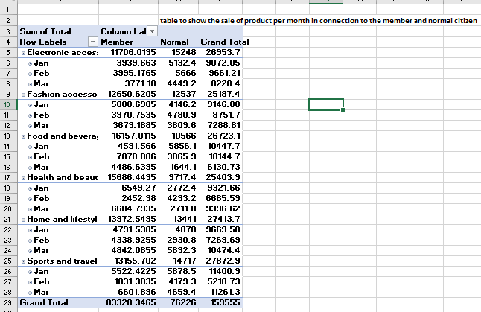

The table above shows the sales per month for the first quarter in relationship with the veteran members and normal citizens

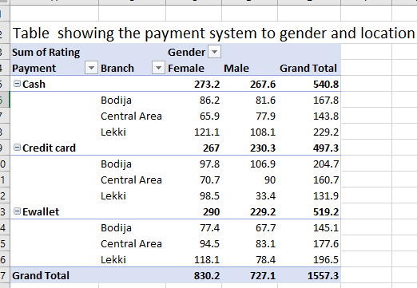

The above shows the mode of payment mode in respect to location and gender. The final pivot table is the table showing the rate of purchases by the customer with respect to their location and unit price

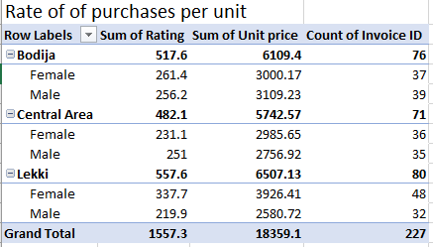

## Dashboard

A dashboard is a visual representation of key performance indicators (KPIs), metrics, and other important data related to a project. Dashboards provide a consolidated view of critical information, allowing project managers and stakeholders to quickly assess the status, progress, and overall health of a project. This dashboard will give Kingston supermarket, directors, and stakeholders a quick performance of the three branches all across Nigeria in the first quarter.

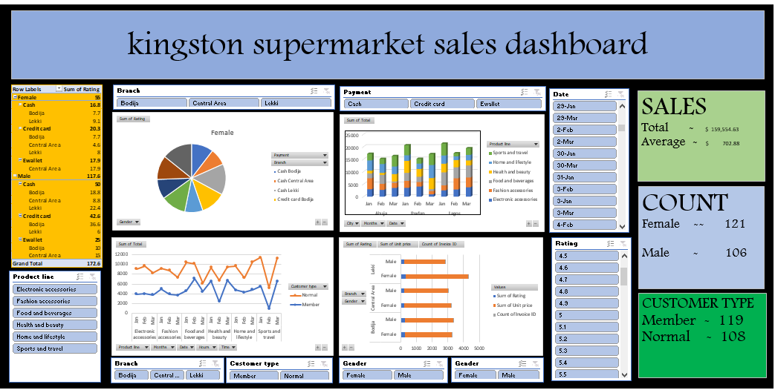

## Conclusion and Recommendation

The business so far is not doing badly, the indices and metrics shows that of great future prospects. In just the first quarter the gross income of the business is 7597.9 which is way ahead of the budget for the first quarter, sales also stand at 319,109 naira while the average on every sale is 1,399 naira. The gross margin percentage stands at 4.8%. These are nice numbers for just the first quarter.

Patronage is also doing great, a total of 277 customers transacted business on different levels, 121 female and 106 male while 119 were members and 108 were normal public citizens the rating is also showing a possible number of 68.6%. The majority of the customers prefer to cash with e-wallets and cards in that order.

The product line did well, products available for analysis were electronic accessories, food and beverages, health and beauty, fashion accessories, sport and travel, and home and lifestyle. Sport and travel were the most sold with the amount of 27,873 naira while fashion accessories did the least with 25,187 naira

Finally, I recommend that the business should seek more expansion because there are prospects for growth, rating from the customer is good and sales are going high. However, more awareness should be done through the media and advsertiment for the normal citizen to patronize more the 108 number is relatively low. If there is more patronage from the public or normal citizens there will be more sales and the figure could be triple or higher.